Compound Poisson distribution

Def

Given:

Expected Value $$l$$ of random variable $$N$$ in Possion distribution.

Suppose:

$$N∼Possion\left(l\right)$$

$$X_{1},…,X_{n}$$ are identicially distributed random variables that are mutally independent.

Then PDF of N is:

$$Y$$ == $$sigma\left(X_{n},n=1,n=N\right)$$

which is in the compound Possion distribution.

Expected



Variance



where the relationship between $$l,alpha,beta$$ and $$mu,p,disp$$ are as follows:

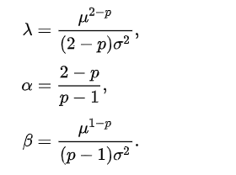

Property

$$E\left[Y\right]$$ = $$E\left[N\right]⋅E\left[X\right]$$

Proof:

$$E\left[Y\right]$$ = $$E\left[E\left[Y\left|N\right|\right]\right]$$ = $$E\left[NE\left[X\right]\right]$$ = $$E\left[N\right]⋅E\left[E\left[X\right]\right]$$ = $$E\left[N\right]⋅E\left[X\right]$$

$$Var\left(Y\right)$$ = $$E\left[N\right]⋅Var\left(X\right)+E{\left[X\right]}^{2}⋅Var\left(N\right)$$

Proof:

$$Var\left(Y\right)$$ = $$E\left[Var\left(Y\left|N\right|\right)\right]+E\left[Var\left(Y\left|N\right|\right)\right]$$ = $$E\left[N⋅Var\left(X\right)\right]+Var\left(N⋅E\left[X\right]\right)$$

= $$E\left[N\right]⋅Var\left(X\right)+E{\left[X\right]}^{2}⋅Var\left(N\right)$$

PGF

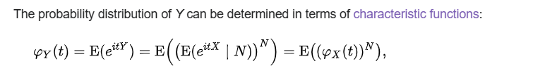

CGF

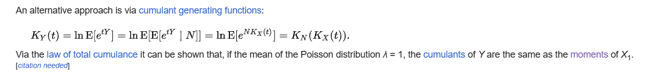

Ref

[Compound Poisson distribution - Wikipedia](https://en.wikipedia.org/wiki/Compound_Poisson_distribution)